Final Name: ______________________

Read and answer all questions, correctly! You may use your book and any class notes. You may not ask others for any answers or for help on the exam. Show all work.

- Using the given ERD, write queries that perform the following functions.

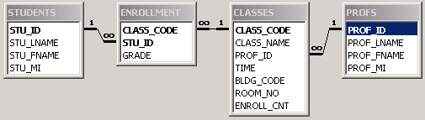

  - List all classes being held at the Capital Center. The building code for the Capital Center is “CC”. Your result should display the name of the class, the time that it meets, and its room number.

  - List the names of all classes being taken by a student whose ID is 246-80-1357. Your result should show only the class names.

  - List all classes in alphabetical order, along with the name of the professor who teaches each class. Your results should show the class code, class name, and professor’s full name.

  - Assume that the GRADE stored in the ENROLLMENT table is a numerical value 0-4. List the student(s) with the highest GPA.

- Identify the redundant data in the ERD in problem 1 not related to foreign keys. Why would you want to keep this redundancy?

- Use the following data dependency diagram to answer the questions below.

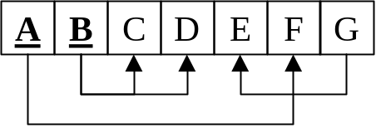

  - What normal form is the data in?

  - Eliminate all redundant data by creating additional tables.

- Eliminate all redundant data in the following data dependency diagram.

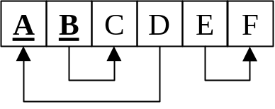

- What purpose does the database log file serve?

- What is two-phase locking, and what problem does it solve?

- Construct an ERD for the following application description. Clearly state any assumptions that you needed to make to complete the E-R Diagram.

  - A database has many tables.
  - Table names are unique.
  - Each table has multiple fields.
  - The field names within a table are unique.
  - A table may be related to zero or more other tables.
  - A field may be one of many data types, such as a string, integer, floating point value, Boolean, etc.
  - Each data type may be used by more than one field
  - The database also stores multiple queries.
  - Each query pulls data from one or more tables. (For a bonus: Allow the data sources for a query to be either tables or other queries.)
  - Each query displays one or more fields from its data sources.

Your final ERD should show all attributes, including primary keys, and all relationships, including if they are optional or mandatory. If you turn in a hand copy of an ERD, it must be readable.

